1. **Develop a simple ASP.NET web form that generates the front cover for a magazine. The form should provide the options for selecting the image, background color, changing font size, colour etc. Input messages must be taken from the user so as to display it on the front cover with legible font family and font size. The controls added must be proportionate to the web page size.**

**Code:**

**CoverGenerator.aspx:**

<%@ Page Language="C#" AutoEventWireup="true" CodeBehind="CoverGenerator.aspx.cs" Inherits="q4.CoverGenerator" %>

<!DOCTYPE html>

<html xmlns="http://www.w3.org/1999/xhtml">

<head runat="server">

<title>Front Cover Generator</title>

</head>

<body>

<form id="form1" runat="server">

<div style="height: auto; width: 100%">

<asp:Panel ID="ConfigureDiv" runat="server" style="padding: 15px; border-style: inset; border-width: medium; height: 705px; width: 300px; font-family: Calibri; font-size: medium; font-weight: bold; background-color: #5C87D8; position: absolute; z-index: auto; display: block; float: left; cursor: auto; clip: rect(auto, auto, auto, auto); color: #FFFFFF; top: 15px; left: 10px; overflow: scroll;">

Choose the bacground image:<br />

<asp:DropDownList ID="ImageDropDownList" runat="server" AutoPostBack="True" OnSelectedIndexChanged="ControlChanged" Height="25px" Width="175px">

<asp:ListItem>None</asp:ListItem>

<asp:ListItem>Abstract Image 1</asp:ListItem>

<asp:ListItem>Abstract Image 2</asp:ListItem>

<asp:ListItem>Abstract Image 3</asp:ListItem>

</asp:DropDownList><br /><br />

Choose the background colour:<br />

<asp:DropDownList ID="BackgoundDropDownList" runat="server" AutoPostBack="true" OnSelectedIndexChanged="ControlChanged" Height="25px" Width="175px"> </asp:DropDownList><br /><br />

Choose the text colour:<br />

<asp:DropDownList ID="TextDropDownList" runat="server" AutoPostBack="True" OnSelectedIndexChanged="ControlChanged" Height="25px" Width="175px"></asp:DropDownList><br /><br />

Choose the font name:<br />

<asp:DropDownList ID="FontDropDownList" runat="server" AutoPostBack="True" OnSelectedIndexChanged="ControlChanged" Height="25px" Width="175px"></asp:DropDownList><br /><br />

Enter the font size:<br />

<asp:TextBox ID="SizeTextBox" runat="server" AutoPostBack="true" OnTextChanged="ControlChanged" Height="16px" Width="175px"></asp:TextBox><br /><br />

Choose the border style:<br />

<asp:RadioButtonList ID="BorderRadioButtonList" runat="server" AutoPostBack="True" OnSelectedIndexChanged="ControlChanged" Height="23px" RepeatColumns="2" Width="175px">

</asp:RadioButtonList><br />

Enter the text to be displayed on the cover:<br />

<asp:TextBox ID="GreetingsTextBox" runat="server" AutoPostBack="True" OnTextChanged="ControlChanged" Height="75px" Rows="2" TextMode="MultiLine" Width="175px"></asp:TextBox>

<br /><br />

<br />

<asp:Button ID="PreviewButton" runat="server" Text="Preview" OnClick="PreviewButton_Click" Height="31px" Width="76px" />

&nbsp;&nbsp;&nbsp;&nbsp;&nbsp;&nbsp;&nbsp;

<asp:Button ID="ClearButton" runat="server" Text="Clear" OnClick="ClearButton_Click" Height="31px" Width="76px" />

<br />

<br />

<br />

<br />

</asp:Panel>

<asp:Panel ID="CoverPanel" runat="server" style="left: 355px; position: absolute; top:18px; background-position: center center" Height="545px" Width="358px" HorizontalAlign="Center">

<br /><br />&nbsp;

<asp:Label ID="GreetingsLabel" runat="server" Height="160px" Width="300px"></asp:Label>

<br />

</asp:Panel>

<asp:Panel ID="EditButtonPanel" runat="server" style="left: 355px; position: absolute; top:583px" Height="30px" Width="358px" HorizontalAlign="Center">

<asp:Button ID="Button1" runat="server" Text="Edit" OnClick="Button1_Click" Width="60px" Height="34px" />

</asp:Panel>

</div>

</form>

</body>

</html>

**CoverGenerator.aspx.cs:**

using System;

using System.Collections.Generic;

using System.Linq;

using System.Web;

using System.Web.UI;

using System.Web.UI.WebControls;

using System.ComponentModel;

using System.Data;

using System.Drawing;

using System.Web.UI.HtmlControls;

using System.Drawing.Text;

namespace q4

{

public partial class CoverGenerator : System.Web.UI.Page

{

protected void Page_Load(object sender, EventArgs e)

{

if (this.IsPostBack != true)

{

//Get list of available colours

string[] colours = Enum.GetNames(typeof(KnownColor));

BackgoundDropDownList.DataSource = colours;

BackgoundDropDownList.DataBind();

BackgoundDropDownList.SelectedIndex = 163;

TextDropDownList.DataSource = colours;

TextDropDownList.DataBind();

TextDropDownList.SelectedIndex = 34;

//Get list of available font families

InstalledFontCollection fonts = new InstalledFontCollection();

foreach (FontFamily family in fonts.Families)

FontDropDownList.Items.Add(family.Name);

//Get the border styles

string[] borderStyles = Enum.GetNames(typeof(BorderStyle));

BorderRadioButtonList.DataSource = borderStyles;

BorderRadioButtonList.DataBind();

BorderRadioButtonList.SelectedIndex = 0;

//Choose default image

ImageDropDownList.SelectedIndex = -1;

//Make cover panel visible

CoverPanel.Visible = true;

//Make edit button not visible

EditButtonPanel.Visible = false;

}

}

private void UpdateCard()

{

//Update the colours

CoverPanel.BackColor = Color.FromName(BackgoundDropDownList.SelectedItem.Text);

GreetingsLabel.ForeColor = Color.FromName(TextDropDownList.SelectedItem.Text);

//Update background image

if (ImageDropDownList.SelectedIndex != 0)

{

string imageURL = "~/Images/" + ImageDropDownList.SelectedItem.Text + ".jpg";

CoverPanel.BackImageUrl = imageURL;

}

else

CoverPanel.BackImageUrl = "";

//Update the font name and size

GreetingsLabel.Font.Name = FontDropDownList.SelectedItem.Text;

try

{

if (Int32.Parse(SizeTextBox.Text) > 0)

{

GreetingsLabel.Font.Size = Int32.Parse(SizeTextBox.Text);

}

}

catch

{

}

//Get the correct TypeConverter for BorderStyle enumeration

TypeConverter converter = TypeDescriptor.GetConverter(typeof(BorderStyle));

//Upfate the border style

CoverPanel.BorderStyle = (BorderStyle)converter.ConvertFromString(BorderRadioButtonList.SelectedItem.Text);

//Set the text

GreetingsLabel.Text = GreetingsTextBox.Text;

}

protected void ControlChanged(Object sender, EventArgs e)

{

//Update and refresh the cover

UpdateCard();

}

protected void PreviewButton_Click(object sender, EventArgs e)

{

//Update and refresh the cover and hide the div

UpdateCard();

ConfigureDiv.Visible = false;

EditButtonPanel.Visible = true;

}

protected void Button1_Click(object sender, EventArgs e)

{

//Make the properties visible to configure and hide the edit button

ConfigureDiv.Visible = true;

EditButtonPanel.Visible = false;

}

protected void ClearButton_Click(object sender, EventArgs e)

{

//Clear entered texts and selections and set it back to default

BackgoundDropDownList.SelectedIndex = 163;

TextDropDownList.SelectedIndex = 34;

BorderRadioButtonList.SelectedIndex = 0;

ImageDropDownList.SelectedIndex = -1;

FontDropDownList.SelectedIndex = -1;

SizeTextBox.Text = "";

GreetingsTextBox.Text = "";

UpdateCard();

}

}

}

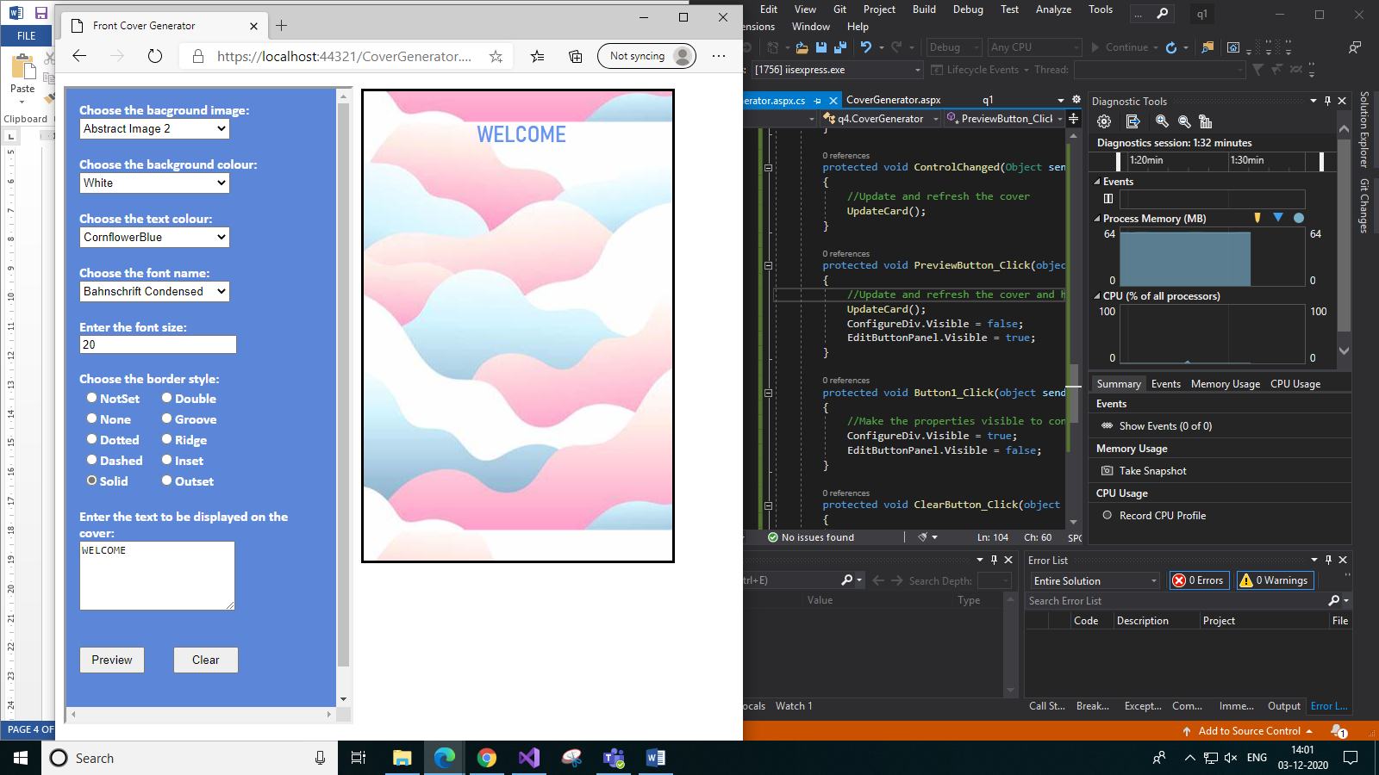**Output:**

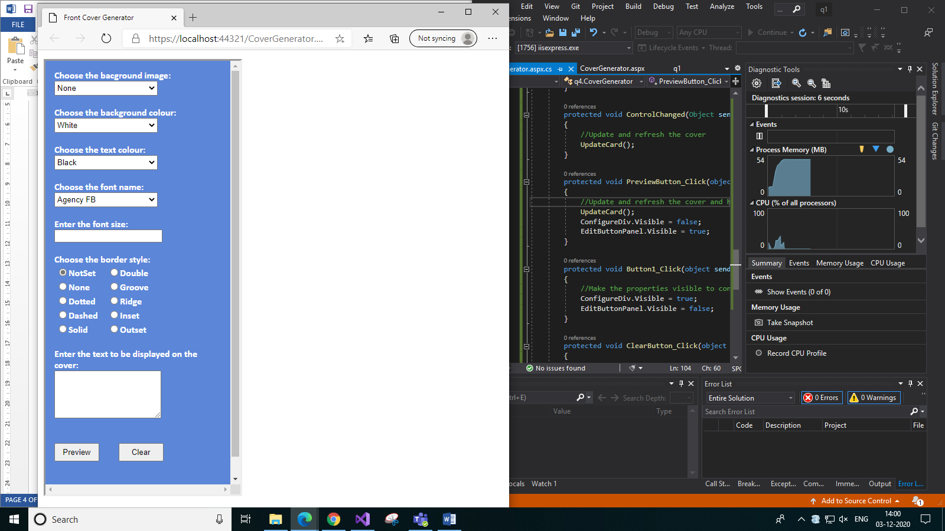

*a) Default configurations. On clicking Clear it will default to this. b) On selecting the properties*

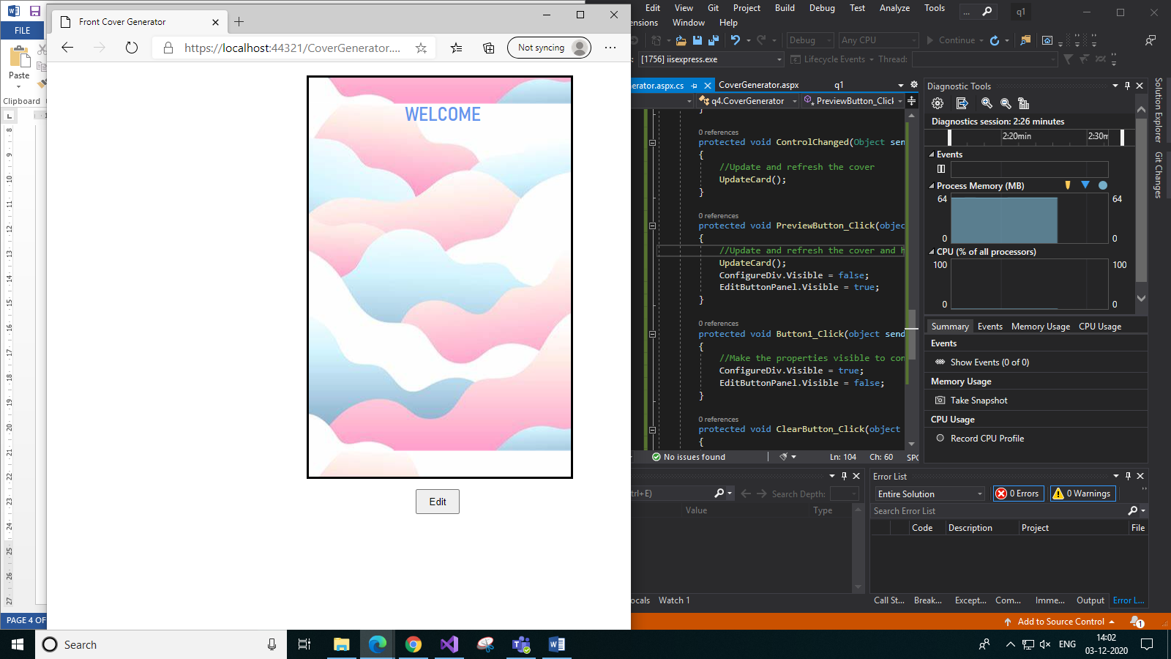

*c) On clicking Preview d) On clicking Edit*